Grid Programming Environment

Xue Bai, Pi-Chieh Sung, YaoDe Wang

Grid Computing and Distributed Systems Laboratory
Dept. of Computer Science and Software Engineering
The University of Melbourne, Australia

Email: {baixue0121, pichiehsung, wangyaode} @gmail.com

Abstract
A new emerging technology, Grids enable the sharing, selection and aggregation of resources that are geographically distributed. Modern Grids offer many types of services such as computational services, data services, application services, information services and knowledge services [10]. However, due to insufficient knowledge of Grid concepts and unfamiliarity with the Grid programming environment, the usage of Grid related technology is hindered somehow. This paper is going to investigate different types of programming environments for Grid. The Grid programming environments discussed are GridRPC [1], Grid Application Toolkit (GAT) [2], and ASSIST [7]. In addition to the different types of programming environments, the fundament concepts of Gridbus broker API [5] will be presented. GridRPC is a middleware that enables remote communication between Client and Server on a Grid. We will look at first the general concept of GridRPC, followed by two of the most prominent projects that have adopted GridRPC system. Next, the idea and the architecture of the Grid Application Toolkit (GAT), ASSIST and Gridbus Broker API will be explored. Comparison and comments on each of the programming environments will also be investigated. Lastly, we will end our investigation with success stories for each of the programming environments.

- Introduction
A new emerging technology, Grids enable the sharing, selection and aggregation of resources that are geographically distributed. Modern Grids offer many types of services such as computational services, data services, application services, information services and knowledge services [10]. In order to provide such functionalities, Grid creates an environment with heterogeneous and distributed characteristics. Without a good programming environment, the application development on Grid would be very tedious and time consuming. Consequently, the development of Grid programming environment is significant and necessary.
As a good programming environment, it should achieve the following goals:
- High-level programmability and productivity for various Grid applications [4]
- Platform independent; that is to support different programming languages. If possible, it should also support different Grid middleware
- Enable the reuse and sharing of the software
- Easy to use
- Enable high performance and low cost implementation

Most Grid programming environments should include interfaces, APIs, utilities and tools as their basic components [4]. It should fully support some of the commonly used programming languages such as C, C++, Java and Fortran (both object oriented and non object oriented). In addition, application programming interfaces such as MPI and PVM should be available [4]. Some of the programming paradigms such as message passing and distributed shared memory should also be included [4].

This paper is going to investigate different types of Grid programming environments such as GridRPC, Grid Application Toolkit (GAT) and ASSIST. We will also analyze Gridbus Broker API on Gridbus system. Related works on various types of Grid programming environments will be tabularized in section 2 based on descriptions, remarks and URL. Since a technical implementation of GridRPC on Gridbus Broker will come after this project, GridRPC is been covered more detailed in section 3. GridRPC is a middleware that enables a remote communication between client and server on a Grid. In our work, we have adopted two prominent projects for the analysis of GridRPC implementation. These two projects are NetSolve [1], which is being developed by the University of Tennessee and Ninf-G [1], which is running under the work of Ninf Project by the AIST Grid Technology Research Center in Japan. Additionally, we have examined some of the basic GridRPC API functions. A brief introduction on Grid Application Toolkit (GAT) will be discussed next. In this section, we have covered the GAT architecture, focused mostly on GAT layer which is mainly comprised by GAT API, GAT engine and adaptors. ASSIST is a programming environment which enables high programmability and productivity on large scale platforms. In section 5, we will take an in-depth look at ASSIST. Lastly, this paper will investigate the idea of Gridbus Broker, one of the main components in Gridbus middleware developed under Gridbus project. Gridbus project is a research project led by the University of Melbourne GRIDS Lab in Australia. The idea of Gridbus broker is to allocate users’ requests to the appropriate resources and schedule the tasks to meet users’ requirements.

Finally, this paper will end with comparison and success stories for each of the programming environments. Different types of programming environments are compared based on their architectures, runtime platform, programming languages, flexibility and distribution model. Success stories for each of the programming environments are taken from industry experiences.
- Related Works
Base on description, remarks and useful URL, the table below is the brief description for each of the programming environments that we are going to investigate. The Grid programming environments that will be discussed are GridRPC, GAT, ASSIST and Gridbus Broker API.

Name | Description | Remarks | URL
GridRPC - NetSolve | NetSolve system is a RPC based client-server system, which allows users to access computational resources. | The NetSolve project is being developed at the University of Tennessee's Computer Science Department. | http://icl.cs.utk.edu/netsolve
GridRPC – Ninf-G | Ninf-G is developed on top of the Globus Toolkit. It has adopted many of the Globus components such as GRAM, GASS and GSI etc. With the aid of Globus Toolkit, Ninf-G has created a flexible running environment for GridRPC. | Ninf-G is re-implemented from Ninf System which is running under the work of Ninf Project. The participants involved are AIST Grid Technology Research Center, Asia-Pacific Grid and PRAGMA. | http://ninf.apgrid.org/
GAT | GAT is a set of application developer APIs which enables access to various types of Grid services provided by GridLab or other third parties. | GAT is developed under EU-funded project by GridLab. The GridLab project is one of the biggest European researches in the development of application tools and middleware for Grid environments. | http://www.gridlab.org/
ASSIST | ASSIST, (a software development system which is based upon Integrated Skeleton Technology) is created by Department of Computer Science, University of Pisa. It is a programming environment for high-performance complex enabling platforms, especially Grids. | This work has been supported by the Italian MIUR FIRB Grid projects (RBNE01KNFP) on High-performance Grid Platforms and Tools, and by the MIUR CNR Strategic Project L 499/97-2000 on High-performance Distributed Enabling Platforms. | http://www.di.unipi.it/groups/architetture/Assist.html/
Gridbus Broker API | The Gridbus broker is developed to take the responsibility of coordinating access to grid resource entities and providing abstract interface to the users or application programmers. | Gridbus project is a research project led by the GRIDS Lab within the Department of Computer Science at the University of Melbourne in Australia. Other participants/sponsors are Australian Research Council, Storage Technology Corporation, Sun Microsystems, VPAC, IBM, and Singapore Computer Systems and etc. | http://www.gridbus.org/broker/
Table 1: Grid Programming Environment

- GridRPC
GridRPC is a middleware that enables a remote communication between client and server on a Grid. The most prominent works adopted GridRPC are NetSolve and Ninf-G. Before proceeding to the implementations of the GridRPC on different types of grid computing systems, let’s examine some of the basic GridRPC API functions.

Like MPI API, GridRPC also needs Initializing grpc_initialize and Finalizing grpc_finalize Functions [1]. Any call before grpc_initialize or after grpc_finalize will fail.

Remote function handle management function is a set of functions that handles the creation and destruction of the functions [1]. This includes grpc_function_handle_default, grpc_function_handle_init, grpc_function_handle_destruct, and grpc_get_handle.

GridRPC call functions can be further categorized based on two properties such as blocking behavior and calling sequences [1]. Like MPI API, a GridRPC call can be either blocking or non- blocking. The calling sequence refers to the manner of the arguments being passed. Based on the combination of these two properties, there are four basic types of call functions such as grpc_call, grpc_call_async, grpc_call_argstack and grpc_call_argstack_async.

Asynchronous GridRPC control functions only apply to non-blocking GridRPC calls [1]. These functions include grpc_probe which checks for the completion of a specific call and grpc_cancel which cancels the specific call.

Asynchronous GridRPC wait functions apply only to non-blocking GridRPC calls [1]. With these functions, the system is able to control the blocking functionality. Some of the functions are grpc_wait, grpc_wait_and and grpc_wait_or etc.

Error reporting functions return the error code and description if there is any failure with GridRPC call. These functions are grpc_perror, grpc_error_string, grpc_get_error and grpc_get_last_error.

With argument stack functions, one is able to determine the way a function is been called at runtime [1]. Argument stack functions are newArgStack, pushArg, popArg and destructArgStack.

NetSolve system is a RPC based client-server system. It allows users to access computational resources, such as hardware and software, distributed across the network. Since NetSolve deploys a similar RPC mechanism, it provides much of the infrastructure needed to implement GridRPC [1]. Currently, the full GridRPC API has been implemented on top of the NetSolve system. NetSolve system architecture comprises three main components such as Client, Server and Agent [1]. The roles and the relationships among them are illustrated below.
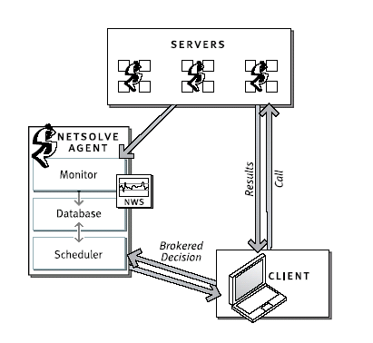
Figure 1: NetSolve System Architecture [1]

- The main role of the Client is to execute some functions remotely. In addition to low-level programming languages, such as C, Fortran and Java, the NetSolve client API is designed to work with high-level mathematics packages, such as Matlab or Mathematica [1].
- The Server executes the requested functions passed from the Clients. Within the NetSolve system, the computational resources are represented by the Servers. The server hardware can be as simple as a uniprocessor and as complex as a MPP system. Like the server hardware, the functions executed by the Server can be complex under certain circumstances [1].
- As being the central part of the NetSolve system, the Agent controls the resources allocation. It also ensures the load balancing of the servers. [1]

Ninf-G is developed on top of the Globus Toolkit [1]. It has adopted many of the Globus components such as GRAM, GASS, GSI, MDS and Globus I/O. With the aid of Globus Toolkit, Ninf-G has created a flexible running environment for GridRPC. For instance, Ninf-G employs Globus Security Infrastructure (GSI); hence all of the components within Ninf-G are well protected by GSI. Furthermore this enables Ninf-G to work with other Globus components in a seamless and secure way [1]. The architecture of Ninf-G is depicted below.
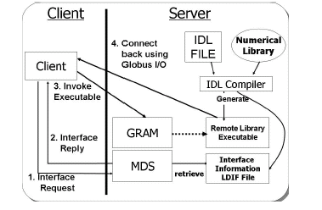
Figure 2: Ninf-G System Architecture [1]

On the Server side, IDL file will go through IDL compiler which will generate Interface information and executable pathname. Pathname specifies the location of remote executable on the Server machine. GRAM (Globus Resource Allocation Manager), MDS (Monitoring and Discovering Service) and Globus I/O are provided by the Globus Toolkit.
Step 1: The Client sends its requests to MDS for interface information and executable pathname retrieval. The retrieval data is then stored with the Client. This is to reduce the overhead communication with MDS [1].
Step 2: MDS replies with the requested information.
Step 3: With the remote executable pathname obtained from MDS in step 1, Client is able to interact with the remote executable (Server) through GRAM. A port address, which will accept the callback from the remote executable, is also provided [1].
Step 4: Remote executable calls back to the Client via Globus I/O.

- Grid Application Toolkit (GAT)
The Grid Application Toolkit (GAT) is running under the Europe-funded project by GridLab. GAT is a set of application developer APIs and is capable of providing a unified simple programming interfaces. The main idea of GAT is to eliminate the needs of the programmers from adjusting their codes when performing tasks on different resources or middleware applications [2].

GAT architecture comprises four main layers such as Application layer, GAT layer, GAT Services layer and Grid Core Services layer [2]. The following diagram depicts GAT architecture:
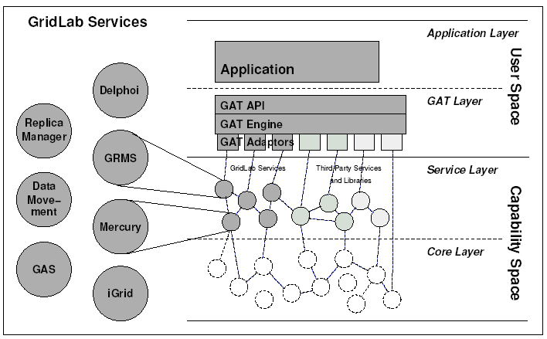
Figure 3: Grid Application Toolkit Architecture [2]

Application Layer
All of the application-specific codes are located at this layer. For instances, Cactus, Triana, Generic Codes, Portals and Scripts. The Application layer utilities the functions provided by the GAT layer.

GAT Layer
This is where the GAT engine and GAT_API located. GAT_API provides functions for Application layer. Examples of GAT_API functions are GAT_FileCopy and GAT_ResourceFind. The GAT Adaptor binds the GAT engine to the Grid services at the Service layer.

GAT Service Layer
All of the Grid services are running at this layer. The services could be implemented by GridLab or provided by other third parties or Grid middleware applications. Services provided by the GridLab are GRMS (The GridLab Resource Management System), GAS (The Grid Authorization Service), iGrid (The GridLab Information Service) etc.

Grid Core Service Layer
Main services such as GRAM, GridFTP, GridSSH and MDS are located at this layer.

As depicted in the diagram, the application layer and the GAT layer are executed in the user space whereas the service layer and the core layer are executed in the capability space. GAT Adaptors are located in between the user space and the capability space. The Adaptor binds the GAT engine at the GAT layer to the Grid services at the Service layer. The services that located at the service layer and the core layer represent the capabilities of the available resources [2].

The GAT engine is a runtime library which exposes the GAT_API to the application [2]. When an application makes a request to GAT_API, the GAT engine will search through the adaptors for the appropriate capabilities. The GAT adaptor, an interface between GAT engine and one or more capabilities, translates the requests into the appropriate syntax for the corresponding capabilities [2].

The GAT_API, an application programming interface can be divided into several subsystems such as File subsystem [2], Resource Management subsystem [2] and Information Exchange subsystem [2], with each handling different Grid services. Although the GAT_API is object-oriented, it is found that non-object oriented implementation is still possible [2].

Other than the implementation flexibility, GAT is also easy to use. Its design is based on plug and play modular such that tools developed elsewhere can be plug into GAT for use without much modifications of software. It supports different programming languages and different Grid middleware systems. Furthermore it allows the same source code to run on a variety of systems. GAT is dynamic oriented as the adaptors located at the GAT layer enable the GAT engine selecting grid services from the Service layer dynamically [2]. GAT can also utilize multiple Grid middleware applications, even with multiple versions, simultaneously [2].

Therefore, based upon these properties, GAT can be viewed as a simple, platform-independent API in Grid programming environment.

- ASSIST
ASSIST is a Grid-aware application that deals with heterogeneity and dynamistic in the most effective way (adaptive applications) [7].

ASSIST Programming Environment is centered on the existence of a high-level, high-performance programming model and related development tools. A high-level view of composition, interoperability, reuse, performance and application adaptive ability characterize the Programming Environment. Applications are expressed entirely on top of this level.

The Grid Abstract Machine level includes all the functionalities to support the preparation, loading and execution of the applications. The Grid Abstract Machine includes the functionalities that are provided by the Middleware tools and services, for instances Connectivity (micro-kernel), Resource (resource management services) and Collective (collective and dynamic resource control and allocation) levels. This Middleware may be one of the current/standard products (Globus Toolkit and its evolutions), or a subset of the services performed by them [7].

Based on the Programming Environment and the Grid Abstract Machine, the programming-model approach to system design is emphasized and, at the same time, the amount and variety of functionalities that are present in the underlying levels is minimized.

Figure 4: The role of Programming Environment in Grid application development [7]

ASSIST is based on the definition and realization of a programming model with the following features:
- Applications are expressed as compositions of high performance components [7]
- A uniform approach is followed by distributed and parallel programming [7]
- The strategies to drive the dynamic adaptation of applications are expressed in the same high-level formalism of the programming model [7]
Figure 5: The conceptual framework for Grid-aware programming environments [7]

Skeleton, a coordination language, is a composition of predefined parallel paradigms. Structured parallel programming, based on the skeletons model, is an approach to deal with the complexity in the design of high-performance applications [7]. It is suitable for homogeneous parallel machines as well as heterogeneous, dynamic platforms, like Grids.

Implementation - Modular design
The ASSIST compiler (namely astcc) produces code for plain POSIX/TCP workstation networks/clusters. The whole ASSIST Coordination Language (ASSIST-CL) compiling tools have a three-tier design:
- Front-end (the top tier) parses ASSIST-CL syntax and produces an internal representation of the program [7].
- Core (the middle tier) translates the internal representation of a program into the task code. The task code represents a sort of C++ template-based, high-level and parallel assembly language [7].
- Back-end (the bottom tier) compiles task code down to the ASSIST abstract machine (CLAM, the Coordination Language Abstract Machine) object code. The CLAM is built on top of POSIX processes/threads and communication (SysV and TCP/IP sockets) primitives. All those primitives are used via the ACE (Adaptive Communication Environment) library [7].
Figure 6: ASSIST compiler at work [7]

Implementation - Supporting heterogeneity
The first design of ASSIST was targeted to homogeneous clusters of Linux machines. Currently, heterogeneous clusters of Intel Linux and MacOSX platforms are supported. It is sufficient to add the builder that produces code suitable for the new architecture. For instance, in the case of POSIX API, the proper builder may be produced with minor revisions of existing ones [7].

Implementation - Configuration
ASSIST-CL programs can be run on a Grid performing the following three steps:
- The XML configuration file is analyzed and the resources needed to execute the program are individuated [7]
- The resources needed to execute the program are gathered, and reserved, using the normal Grid middleware tools (e.g. those provided by the Globus toolkit) [7]
- The XML file is modified in such a way that the resources gathered are used to run the ASSIST code [7]

- Gridbus Broker
In Grid computing system, the computational and data resources are geographically distributed in a large-scale area. These resource entities are characterized by varied owners, administration policies, access methods and capacities [5]. In such heterogeneous parallel and distributed computing environment, how to coordinate these autonomous resources and make the clients access them in an easy and efficient way is the essential part of the whole Grid computing system.

Resource broker plays an important role to address the issues mentioned above. It hides the complexity and details (such as resource availability, access method, security issues, etc.) in the underlying grid layers, and provides an abstract and more general interface to the clients who want to carry out their tasks by deploying the distributed resources of the grid computing system.

In the Gridbus Project, the Gridbus broker is developed to take the responsibility of coordinating access to grid resource entities and providing abstract interface to the users or application programmers. It is designed to have the features of simplicity, modularity, reusability, extensibility and flexibility [5].

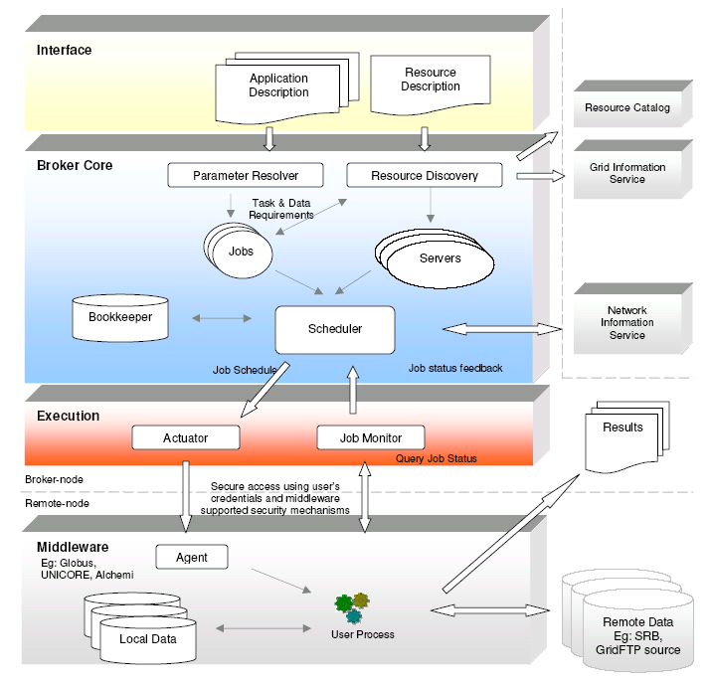
Figure 7: Gridbus Broker Architecture [5]

As shown in Figure 7, the Gridbus broker consists of three main sub-systems, which are application interface sub-system [5], broker core sub-system [5] and execution sub-system [5].

The Gridbus broker is designed to provide programmers the ability to access most of the common broker APIs used internally, as well as the basic usage as a stand-alone command-line program. Thus, the programmers can easily integrate the broker into their own programs for further development.

As the Gridbus broker is implemented in Java, it can be used as an API within other programs by simply copying the gridbroker.jar [5] into the Java libraries. The main entities in the common broker APIs are:
- Farming Engine [5]: It acts as the central component in the broker, maintaining the broker’s current state at any point of time. It is responsible for binding all the components together, interacting with external application and initiating the scheduling.
- Scheduler [5]: A component deployed to map the jobs to nodes on the grid system. It is underlying platform independent and schedules tasks based on metrics. Gridbus broker includes three built-in schedulers, which are economy-based scheduler [5], data-aware scheduler [5] and economy and data-aware scheduler [5].
- Job [5]: An abstraction for a unit of work assigned to a node in the grid system, consisting of two parts such as Variables and Task [5]. A variable keeps the designed parameter value for a job, and a task holds the description of that job.
- ComputeServer [5]: It holds the descriptions and properties for a node on the grid, including an associated JobMonitor and ComputeServerManager. These three components are all middleware independent.
- DataHost [5]: The nodes on which data files have been stored. It keeps the information of the data files and a list of the compute resources stored in the descending order of available bandwidth of the host [6].
- DataFile [5]: It holds the related information of the input files required for an application. Each DataFile links to the different DataHosts that store that file [6].

Further more, the Gridbus broker can also be used within a portlet [5] environment to develop the Gridbus Broker portlets which have the advantages of reusability and portability and are becoming a promising technology.

Overall, the model of Gridbus broker is parameter-sweep design basis. [7] It is simple, extensible, and service oriented. Additionally, it is both platform and middleware independent.

- Comparison of Grid Programming Environments
Table 2 is the result of comparison for each type of programming environments discussed in the previous sections. The comparison is based upon system architecture, runtime platform, programming languages, flexibility in terms of platform and middleware, and distribution model.

Prog Environment  Property | GridRPC | GAT | ASSIST | Gridbus Broker API
Architecture | Client/Server model | Layered component model | Parallel programming and object model | Hourglass model
Runtime Platform | Depends on underlying architecture | Windows-9x, Windows-NT4, Linux, Unix, MacOS-x. | POSIX/ACE Linux workstation networks | Unix, Windows with .NET
Programming Languages | Most are C | Both oriented and non- oriented programming languages are applicable. | Sequential portion: C, C++ and Fortran77.  Parallel portion: ASSISTcl | Java, C, C#, Perl
Flexibility | Depends on underlying architecture. | Both platform and middleware independent. | Both platform and middleware independent. | Both platform and middleware independent.
Distribution Model | Open source | Open source | Open source | Open source
Table 2: Comparison of each of the Grid Programming Environments

- Success Stories
A successful Grid application should hide the complexity of Grid from its users. Both users and application programmers do not have to understand the underlying processes of Grid services and resources allocation. As the result, Grid technology is been widely involved in many world- wide projects and applied to a various ranges of industry.

The Grid Application Deployment (GAD) Kit [11] is a user-friendly tool that is designed to help users on building GridRPC functions, monitoring Grid resources and deploying their applications on Grid environment [11]. It acts as a GridRPC services provider. Meanwhile it also covers metascheduling and load balancing [11]. GAD is developed by Nanyang Campus Grid in Singapore. Other representative projects adopting GridRPC are NetSolve and Ninf-G. Both projects have shown a promising trend in the future.

GAT is been successfully applied across different ranges of industry. On the demonstrations of Supercomputing 2003 conference in Phoenix, USA, GAT has been applied on Cactus application. Cactus is an application for the analysis of astrophysical phenomena such as black holes, colliding neutron stars, singularities, gravitational waves and similar effects [9]. As illustrated by Jarek Nabrzyski, the application department manager of Poznan Supercomputing and Networking Centre (PSNC), Cactus requires a very high need of processing power. "Simulating the collision of black holes in space, for example, can require three weeks of computing on a one thousand processor machine. Using the Grid enables us to make use of various distributed processing resources at the same time, and decrease the time required by a factor of three to five." [9] Nabrzyski also highly rated the capability of GAT by saying that “The most important advantage for Grid users is that they have a single tool that allows them to use the Grid in the simplest possible way. That is the big advantage of GAT. People developing their applications for the Grid can take the GAT and they have everything they need." [9]

ASSIST has successfully been implemented on POSIX/ACE Linux workstation networks. This demonstrates high portability of ASSIST. In addition, ASSIST demonstrates good scalability when running on Linux clusters.

Gridbus broker is been successful in many applications such as High Energy Physics (EPP, School of Physics), Astronomy (Astronomy group, School of Physics), Brain Activity Analysis (Osaka University, Japan), Natural Language Engineering (NLE Group, CS Department), and Finance Modelling (Complutense University of Madrid). [7]

- Our Proposal
In this paper, we have emphasized on the general concepts and basic architecture of different types of Grid programming environments. This is to give us more understandings on Grid programming environment as we are going to implement GridRPC functions on Gridbus Broker in the next project.

- Summary and Conclusions
Currently, there is a significant amount of efforts being put on to the development of Grid programming environment. Since the computational and data resources are geographically distributed in a large-scale area in Grid, the development of a good programming environment that can fulfill such needs is significant and necessary.

It can be shown from our investigation that most of the programming environments have aimed at achieving high-level programmability and productivity, platform independent, software reuse and sharing, and user-friendly. Each type of the programming environments has a significant amount of contributions to various fields across different industries or areas.

- References
[1] Keith Seymour, Hidemoto Nakada, Satoshi Matsuoka, Jack Dongarra, Craig Lee, Henri Casanova, Overview of GridRPC: A Remote Procedure Call API for Grid Computing, Grid Computing - Grid 2002, LNCS 2536, pp. 274--278, November 2002.
[2] Gabrielle Allen, Kelly Davis, Tom Goodale, Andrei Hutanu, Hartmut Kaiser, Thilo Kielmann, Andre Merzky, Rob van Nieuwpoort, Alexander Reinefeld, Florian Schintke, Thorsten Schütt, Ed Seidel, Brygg Ullmer. The Grid Application Toolkit: Towards Generic and Easy Application Programming Interfaces for the Grid. Proceedings of the IEEE, Vol. 93, No. 3, pp. 534-550, March 2005.
[3] Thomas M. Eidson, Grid Programming Environments: A Component-compatible Approach, <http://www.eece.unm.edu/~apm/WhitePapers/eidsonV2.html>.
[4] Domenico Laforenza, Programming High Performance Applications in Grid Environments, Proceedings of the 8th European PVM/MPI Users' Group Meeting on Recent Advances in Parallel Virtual Machine and Message Passing Interface, September 23 - 26, 2001.
[5] Krishna Nadiminti, Srikumar Venugopal, Hussein Gibbins, and Rajkumar Buyya, The Gridbus Grid Service Broker and Scheduler (2.0) User Guide, Technical Report, GRIDS-TR-2005-4, Grid Computing and Distributed Systems Laboratory, University of Melbourne, Australia, April 22, 2005.
[6] Srikumar Venugopal, Rajkumar Buyya and Lyle Winton, A Grid Service Broker for Scheduling Distributed Data-Oriented Applications on Global Grids, Technical Report, GRIDS-TR-2004-1, Grid Computing and Distributed Systems Laboratory, University of Melbourne, Australia, February 2004.
[7] M. Aldinucci, M. Coppola, M. Danelutto, M. Vanneschi, C. Zoccolo, ASSIST as a Research Framework for High-performance Grid Programming Environments, Technical report, Dept. Computer Science, University of Pisa, February 16, 2004.
[8] Srikumar Venugopal, The Gridbus Broker for Service-Oriented Grid Computing, Lecture Notes, Grid Computing and Distributed Systems (GRIDS) Laboratory, Dept. of Computer Science and Software Engineering, University of Melbourne.
[9] Jarek Nabrzyski, Making the Grid transparent to users (2004) Innovation Report <http://www.innovations-report.com/print/print_en01.php3?id=24717&ctyp=1> at 29th April 2005.
[10] M. Baker, R. Buyya, and D. Laforenza, Grids and Grid Technologies for Wide-Area Distributed Computing, International Journal of Software: Practice and Experience (SPE), Volume 32, Issue 15, Pages: 1437-1466, Wiley Press, USA, December 2002.
[11] Q. T. Ho, Y. S. Ong, W. T. Cai, H. K. Ng, and B. S. Lee, GAD Kit - A Toolkit for Gridifying Applications, Fifth International Conference on Parallel and Distributed Computing, Applications and Technologies, December 2004.

